**LAB # 11**

**Task #1: You have to create an Android application on which user can create multiple threads by pressing a button multiple time. Each thread must be represented by a progress bar having total 100 steps. Cost of each step is assumed to be 500ms.**

**Solution:**

**Design:**

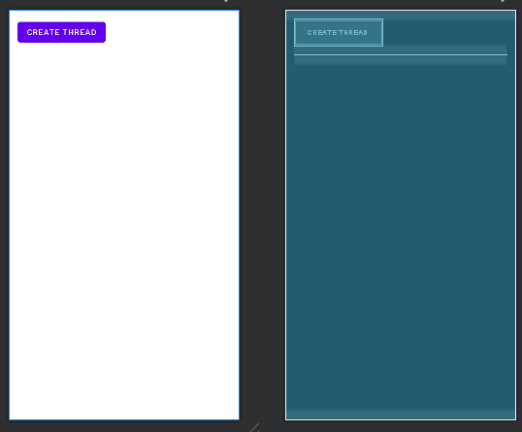

**Code:**

**Progress Runnable Class:**

private class ProgressRunnable implements Runnable {

private final ProgressBar progressBar;

ProgressRunnable(ProgressBar progressBar) {

this.progressBar = progressBar; }

@Override

public void run() {

for (int progress = 0; progress <= 100; progress++) {

try {

Thread.sleep(500);

} catch (InterruptedException e) {

e.printStackTrace();

}

final int currentProgress = progress;

runOnUiThread(new Runnable() {

@Override

public void run() {

progressBar.setProgress(currentProgress);

} }); } } }}

**MainActivity Class:**

public class MainActivity extends AppCompatActivity {

private Button createThreadButton;

private LinearLayout progressContainer;

@Override

protected void onCreate(Bundle savedInstanceState) {

super.onCreate(savedInstanceState);

setContentView(R.layout.activity_main);

createThreadButton = findViewById(R.id.createThreadButton);

progressContainer = findViewById(R.id.progressContainer);

createThreadButton.setOnClickListener(new View.OnClickListener() {

@Override

public void onClick(View v) {

createNewThread();

}

});

}

private void createNewThread() {

ProgressBar progressBar = new ProgressBar(this, null, android.R.attr.progressBarStyleHorizontal);

progressBar.setMax(100);

progressBar.setProgress(0);

progressContainer.addView(progressBar);

Thread thread = new Thread(new ProgressRunnable(progressBar));

thread.start();

}

**Output:**

